# Technical Solution Description

CONTENT

# DESCRIPTION USED TECHNOLOGIES AND FRAMEWORKS SCHEME OF DATABASE

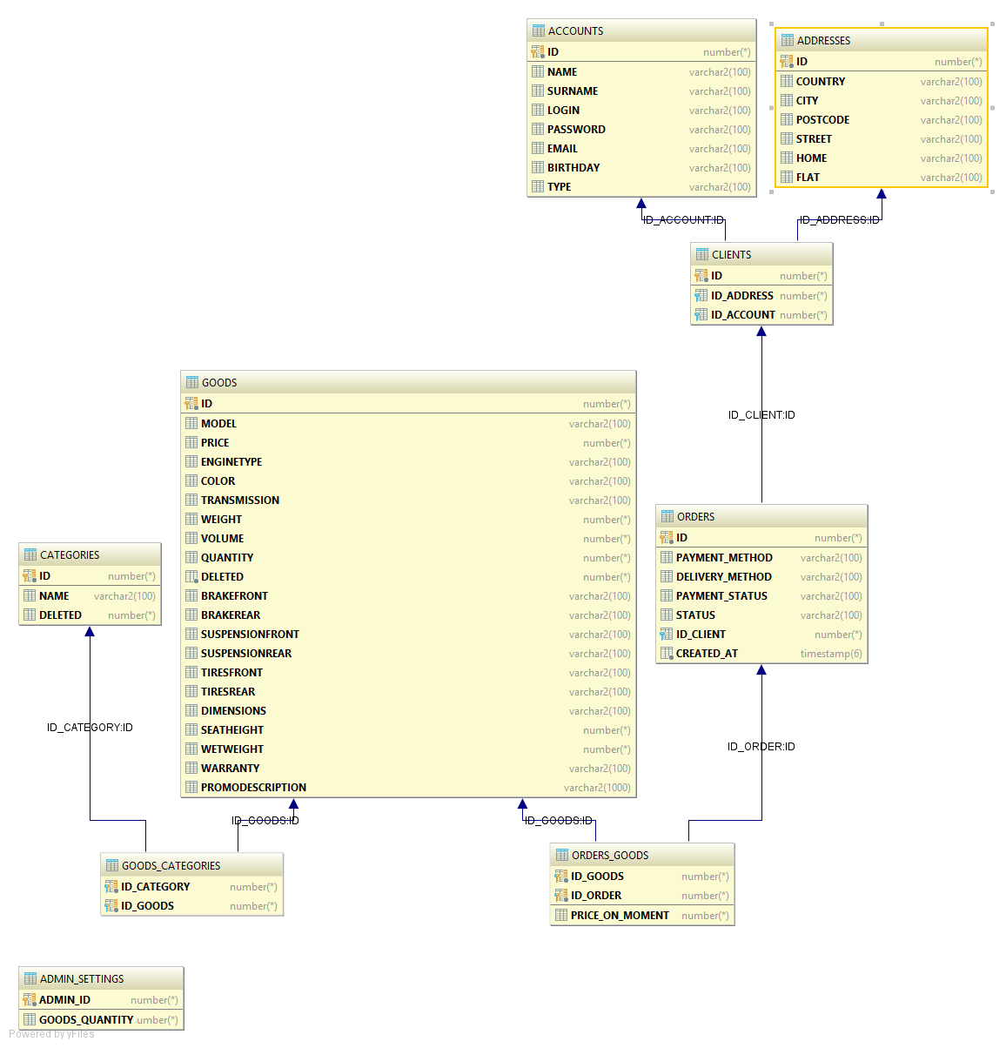

# MODULES OF THE APPLICATION FUNCTIONALITY IMPROVEMENTS IN THE NEXT RELEASES